|  |  |
| --- | --- |
| **GDPARCM Lecture – Basic Thread Handling** | Instructor: Neil Patrick Del Gallego |

Recall that:

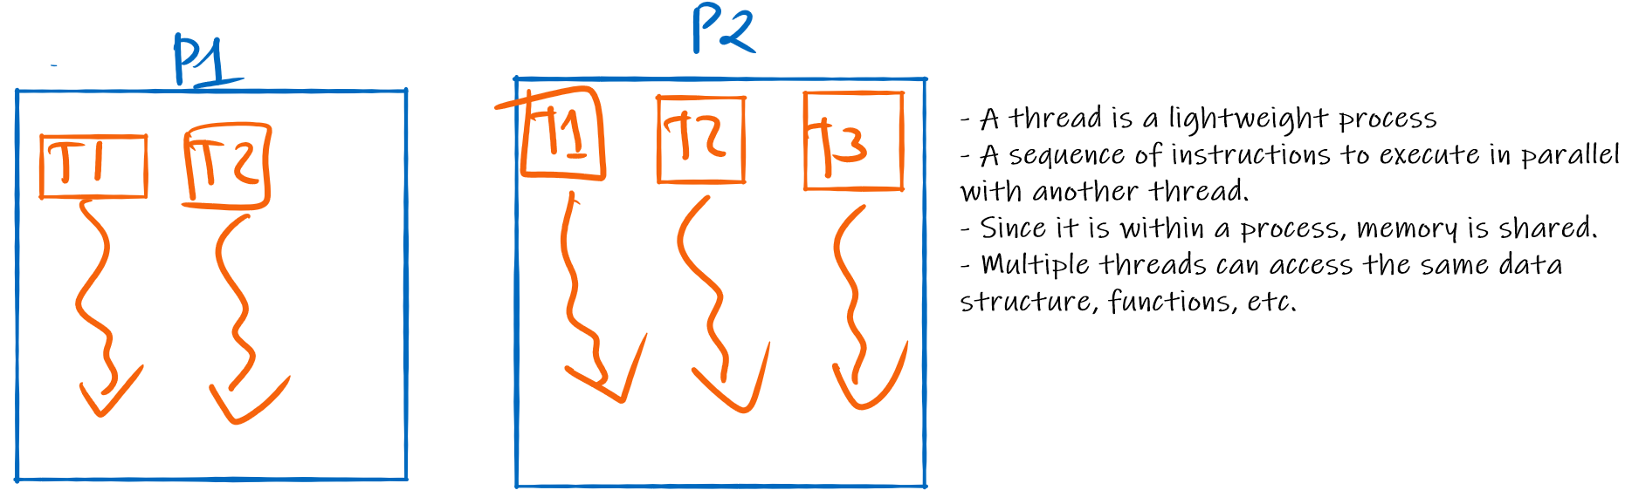

Discussing previous hello world thread. C++ has a guarding mechanism that forces the developer to call either join() or detach(). Why?

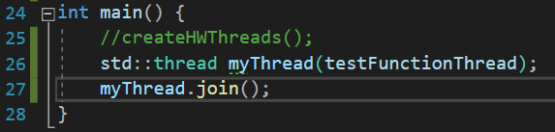

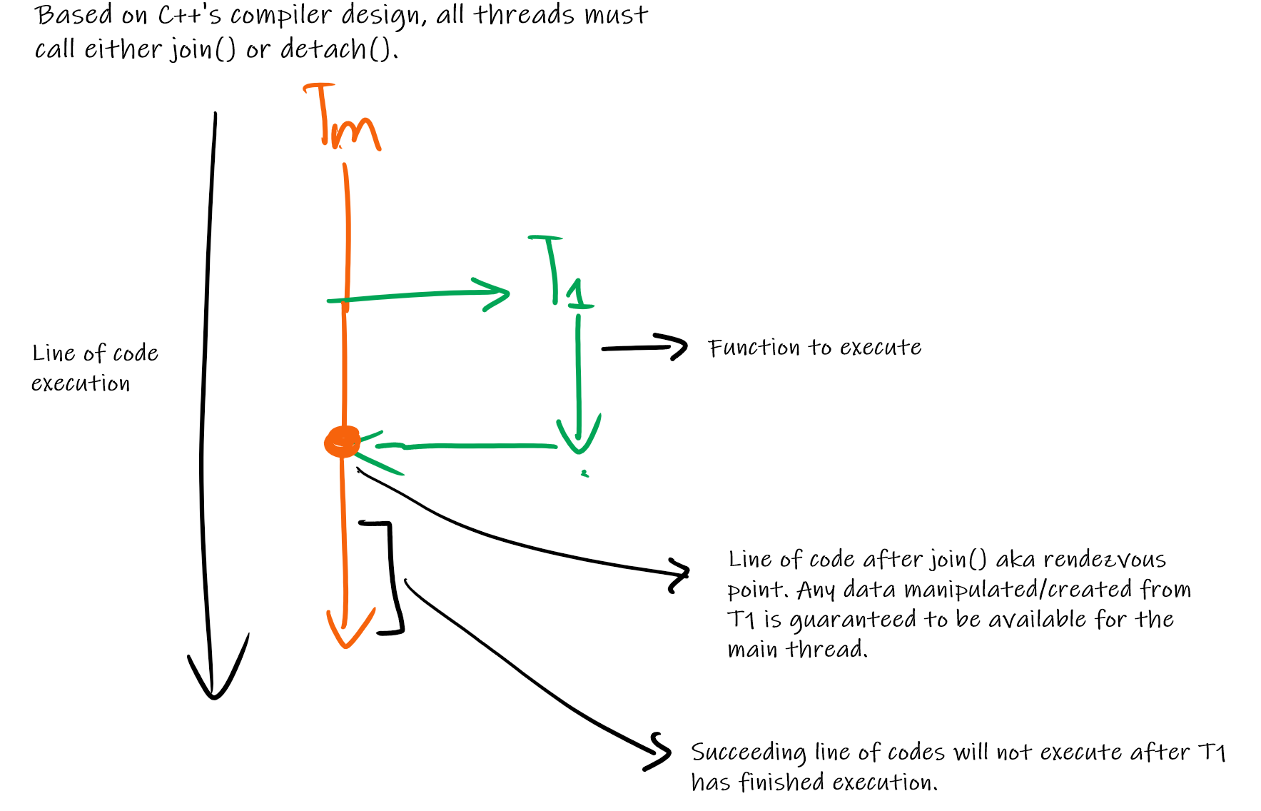

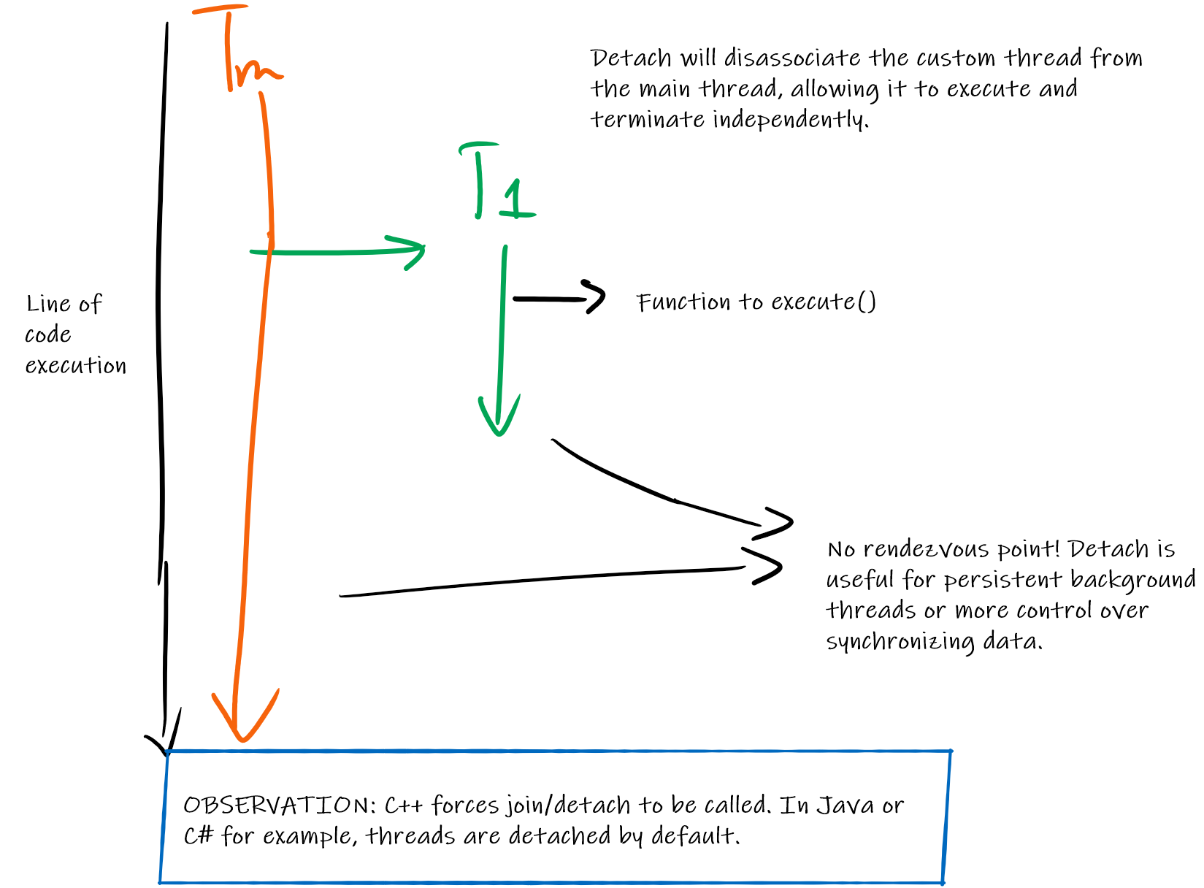

**What to discuss next?**

Discuss the class implementation of IET Thread for OOP thread handling.

**What to discuss next?**

Discuss hands-on activity on using threads with SFML. GDPARCM_HO2 and GDPARCM_HO3.

Prerequisites: The students should have SFML setup and C++ working.

GDPARCM_HO2 = This is an application that is single-threaded. The assets are loaded into the screen with a fixed time delay. Since there is no background thread, this causes the frame rate to drop.

SOLUTION: Use a background thread.

GDPARCM_HO3 = While using background threads to speed up loading. This application modifies the threading part, such that a batch of assets will be loaded all at once, in the hopes of making it faster. 1 asset = 1 thread. Notice that spawning a huge number of threads all at once will cause the frame rate to drop again.

SOLUTION: Limit number of threads by enforcing thread pooling.

**Activity**

Assumption: All threads are detached by default.

* Create N independent threads that periodically print different print statements. All threads are persistent until the main thread has stopped.

|  |
| --- |
| void main() {  int numThreads = 100;  MyThread[] threadList = new MyThread[numThreads];    for(int i = 0; i < numThreads; i++) {  MyThread thread = new MyThread(i);  threadList[i] = thread  **threadList[i].start();**  }    sleep(10000);P  for(int i = 0; i < numThreads; i++) {  **threadList[i].dismiss();**  }  }  class MyThread {  int id;  bool running = false;    public MyThread(int id) {  this.id = id  }P    public void dismiss() {  this.running = false;  }    void run() {  this.running = true;    while(this.running) {  print("Hello I am thread #: ", this.id);    sleep(1000);  }  }  } |

* Create an application that sorts N arrays independently. Once finished, print each array separately.

|  |
| --- |
| void main() {  int batchSize = 100;  int[][] batchArrays = <assume each array is instantiated with random size>  MyThread[] threadList = new MyThread[batchSize];    for(int i = 0; i < batchSize; i++) {  MyThread thread = new MyThread(i);  threadList[i] = thread  threadList[i].start();  }    **<do not use sleep for waiting!>**    bool standby = true;    while(standby) {  for(int i = 0; i < batchSize; i++) {  standby = false;  if(threadList[i].isRunning()) {  standby = true;  break; //if > 1 thread is running, set standby = true  }  }    }  }  class MyThread {  int id;  int[] array;  bool running = false;    public MyThread(int id, int[] toSort) {  this.id = id  this.array = toSort;  }    void run() {  this.running = true;  sort(this.array);  this.running = false;  }    public bool isRunning() {  return this.running;  }  } |

* Create an application that sorts a single array. Partition the array as evenly as possible, given **M** threads. Once finished, print the array.

|  |
| --- |
| void main() {  int arrayToSort = <some array to sort>  int numThreads = <some number of threads>    int division = floor(arrayToSort.length / numThreads);    int lowerB = 0;  int upperB = division;  for(int i = 0; i < numThreads; i++) {  MyThread thread = new MyThread(i, lowerB, upperB);  threadList[i] = thread  threadList[i].start();    lowerB = upperB + 1;  upperB = upperB + division  }    <do not use sleep for waiting!>    bool standby = true;    while(standby) {  for(int i = 0; i < numThreads; i++) {  standby = false;  if(threadList[i].isRunning()) {  standby = true;  break; //if > 1 thread is running, set standby = true  }  }    }  }  class MyThread {  int id;  int[] array;  bool running = false;    int lowerB, upperB;    public MyThread(int id, int[] toSort, int lowerB, int upperB) {  this.id = id  this.array = toSort;  this.lowerB, upperB = lowerB, upperB;  }    void run() {  this.running = true;  **sort(this.arraym, lowerB, upperB);**  this.running = false;  }    public bool isRunning() {  return this.running;  }} |

* Create an application that checks if a given range of numbers is prime. The application should use N-independent threads to check different portions of the range.

|  |
| --- |
| class PrimeCheckerThread extends Thread {  private int start;  private int end;  private boolean isPrime[];  public PrimeCheckerThread(int start, int end, boolean[] isPrime) {  this.start = start;  this.end = end;  this.isPrime = isPrime;  }  public void run() {  for (int i = start; i <= end; i++) {  if (isPrime[i]) { // check only if not already marked as non-prime  for (int j = i * i; j <= end; j += i) {  isPrime[j] = false; // mark multiples as non-prime  }  }  }  }  }  public class PrimeNumberChecker {  public static void main(String[] args) {  int n = 100000; // range of numbers to check  int numThreads = 4; // number of threads  boolean[] isPrime = new boolean[n + 1];  Arrays.fill(isPrime, true); // initially assume all numbers are prime  PrimeCheckerThread[] threads = new PrimeCheckerThread[numThreads];  int rangePerThread = n / numThreads;  for (int i = 0; i < numThreads; i++) {  int start = i * rangePerThread + 1;  int end = (i + 1) * rangePerThread;  if (i == numThreads - 1) {  end = n;  }  threads[i] = new PrimeCheckerThread(start, end, isPrime);  threads[i].start();  }  for (Thread thread : threads) {  try {  thread.join();  } catch (InterruptedException e) {  e.printStackTrace();  }  }  // Print prime numbers  for (int i = 2; i <= n; i++) {  if (isPrime[i]) {  System.out.print(i + " ");  }  }  }  } |

* Create an application that searches for a specific character subset in a very long string. The application should use N independent threads to search different areas of the string.

|  |
| --- |
| class SubsetSearchThread extends Thread {  private String string;  private String subset;  private int startIndex;  private int endIndex;  private boolean found;  public SubsetSearchThread(String string, String subset, int startIndex, int endIndex) {  this.string = string;  this.subset = subset;  this.startIndex = startIndex;  this.endIndex = endIndex;  this.found = false;  }  public void run() {  for (int i = startIndex; i <= endIndex && !found; i++) {  if (string.substring(i, Math.min(i + subset.length(), string.length())).equals(subset)) {  found = true;  }  }  }  public boolean isFound() {  return found;  }  }  public class SubsetSearcher {  public static void main(String[] args) {  String longString = "This is a very long string with a hidden subset to find.";  String subset = "hidden";  int numThreads = 4;  int stringLength = longString.length();  int rangePerThread = stringLength / numThreads;  SubsetSearchThread[] threads = new SubsetSearchThread[numThreads];  for (int i = 0; i < numThreads; i++) {  int start = i * rangePerThread;  int end = Math.min((i + 1) * rangePerThread, stringLength - 1);  threads[i] = new SubsetSearchThread(longString, subset, start, end);  threads[i].start();  }  for (Thread thread : threads) {  try {  thread.join();  } catch (InterruptedException e) {  e.printStackTrace();  }  }  boolean found = false;  for (SubsetSearchThread thread : threads) {  if (thread.isFound()) {  found = true;  break;  }  }  if (found) {  System.out.println("Character subset found in the string.");  } else {  System.out.println("Character subset not found in the string.");  }  }  } |